

ECE302 Embedded Systems Design

Assignment 4

Section 1

Submitted to faculty: [Anurag Lakhlani](mailto:anurag.lakhlani@ahduni.edu.in)

Date of Submission: November 19, 2021

Student Details

| Roll No. | Name of the Student | Name of the Program |
| --- | --- | --- |
| AU1940049 | Sameep Vani | BTech CSE |

2021-2022 (Monsoon Semester)

**Experiment 1**

Experiment Set-Up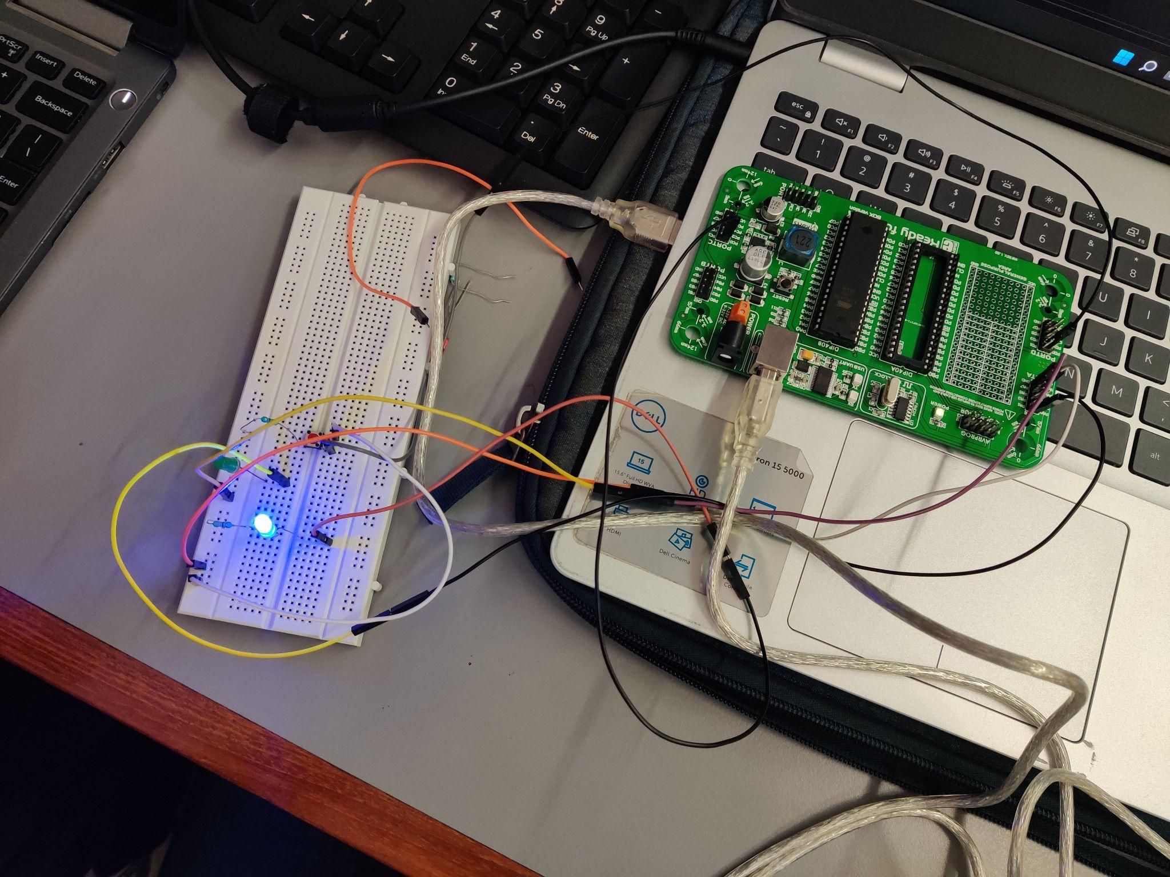

Description

In this experiment, we had to create a circuit to blink the LED at PORTC.b0 with a delay of 1 second. Then on pressing a button, the code will trigger an external interrupt which will make PORTA.b0 blink two times at a frequency of 1 Hz. Then, the circuit resumes normally by blinking LED at PORTC.b0. For this, note that the external interrupt is caused because of the connection between the switch and PORTD.b2. Along with this, there are two LED’s one of these is connected to PORTC.b0 and another one is connected to PORTA.b0.

Video

[Link](https://drive.google.com/file/d/1Q23nohcm3PlcANdQkeZbBCLurEos-zmu/view?usp=sharing)

Code

void main() {

DDRA = DDRC = 0x01;

SREG.b7 = 1; // Global Interrupt

MCUCR = 0x03; // Local External Interrupt Rising edge

GICR = 1<<INT0;

while(1)

{

PORTC ^= 0x01; // Toggle port

Delay_ms(1000); // Apply delay

}

}

void INT0_VECT() org 0x002

{

PORTC = 0x00;

PORTA = 0x01;

Delay_ms(500);

PORTA = 0x00;

Delay_ms(500);

PORTA = 0x01;

Delay_ms(500);

PORTA = 0x00;

Delay_ms(500);

}

Circuit Diagram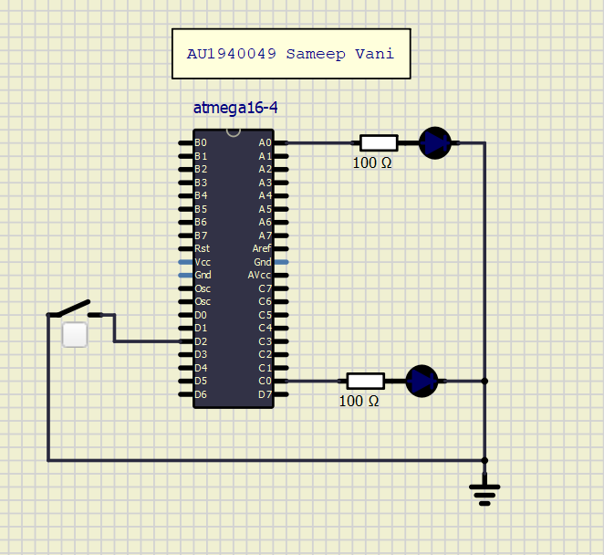

**Experiment 2**

Experiment Set-Up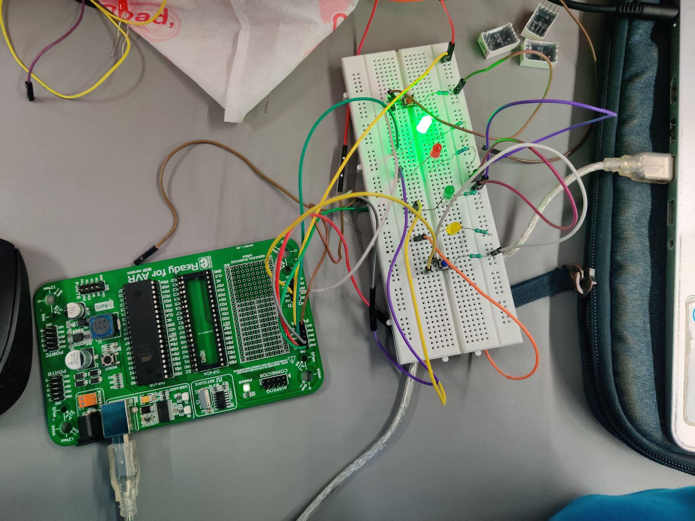

Description

In this experiment, we needed to build a circuit that has two interrupts (INT0 and INT) connected to PORTD.b2 and PORTD.b3 which are connected to two switches. Furthermore, there should be a delay of 0.5 seconds between each pattern. For this, we connected the 4 LEDs to the first four pins of the PORTA. On pressing the switch, there should be a toggle between the two patterns. Also, we used any logical change for interrupt and global variable that determines the pattern that needs to be reproduced.

Video

[Link](https://drive.google.com/file/d/1rNYJU7hGzJQ_aSkur90x-aT_1tPH0or-/view?usp=sharing)

Code

int count = 0;

int left = 1;

void main()

{

DDRA = 0x0F; //L is 2nd and R is 3rd

DDRB = 0x00;

GICR = 0xC0;

MCUCR = 0xFF;

SREG.b7 = 1;

while (1)

{

if (left == 1)

{

for (count=0; count <= 3; count++)

{

PORTA = 1<<count;

Delay_ms(500);

if(left==0){

break;

}

}

}

else

{

for (count=3; count >= 0; count--)

{

PORTA = 1<<count;

Delay_ms(500);

if(left==1){

break;

}

}

}

}

}

void INT0_VECT() org 0x02

{

left=1;

}

void INT1_VECT() org 0x04

{

left=0;

}

Circuit Diagram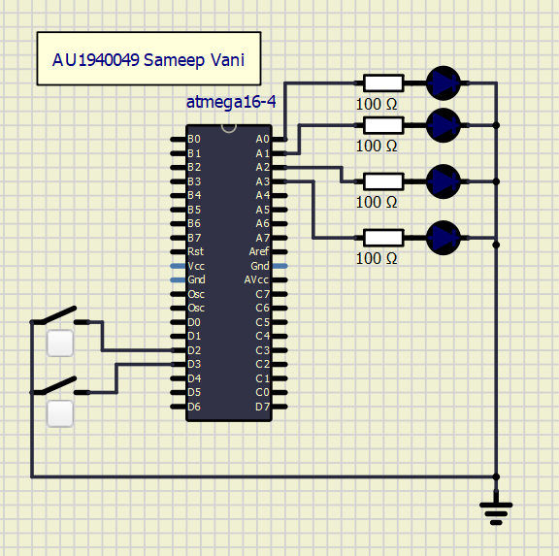

**Experiment 3**

Experiment Set-Up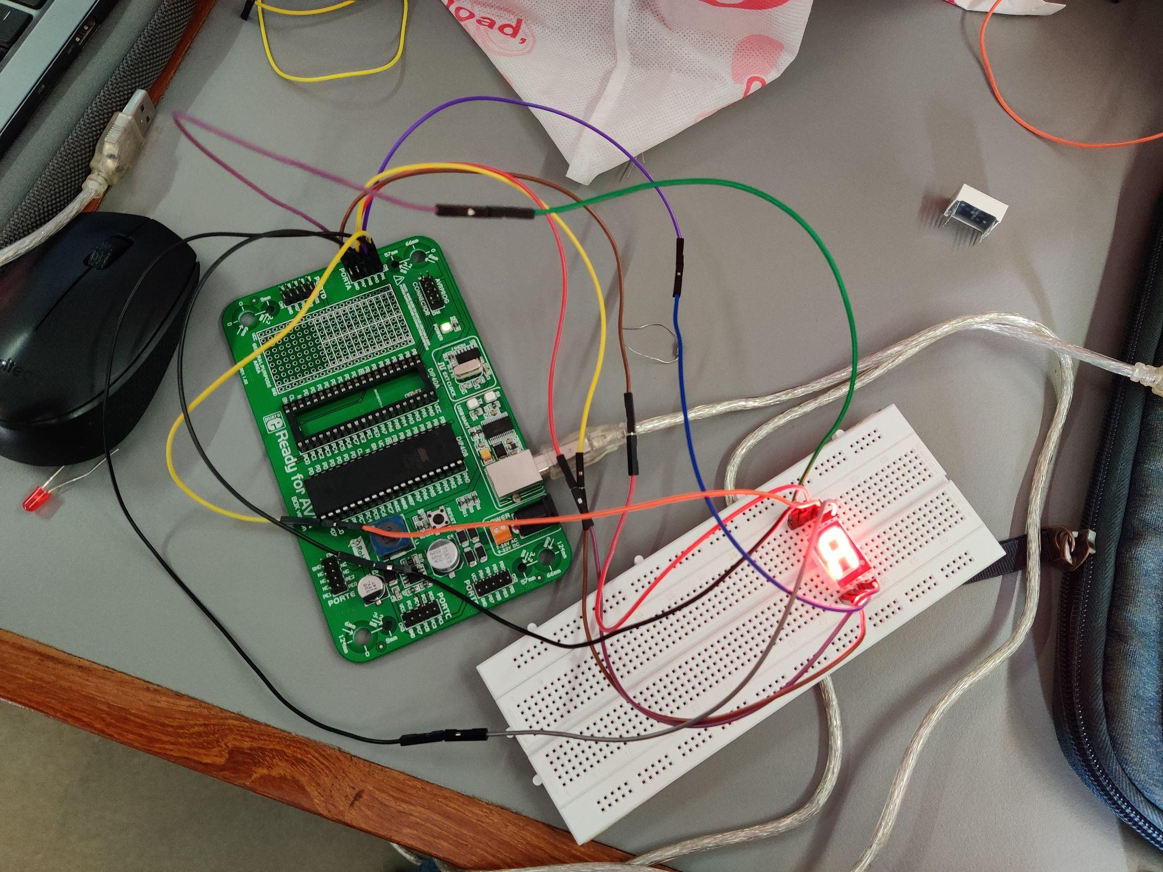

Description

In this experiment, we had to build a circuit that displays “A” on 7 segments LED. The connections of 7 segment LED are quite simple. If Vcc is connected to a common point then it is called a common cathode and vice versa. Further, if using a common cathode and logic 0 is passed, then the LED will turn on. Then according to the figure shown in class, the connections between 7 segment LED and AVR microcontroller. Also, note that GND of the microcontroller and DP point of LED is not connected because these are not required.

Video

[Link](https://drive.google.com/file/d/12XbaUt_J_v1h8eFGQtsGgEXjvOZe4zFU/view?usp=sharing)

Code

int main()

{

DDRA = DDRB = 0xFF;

while(1)

{

PORTA = 0x08; // Display A

PORTB.b0 = 1; // Enable pin

}

return 0;

}

Circuit Diagram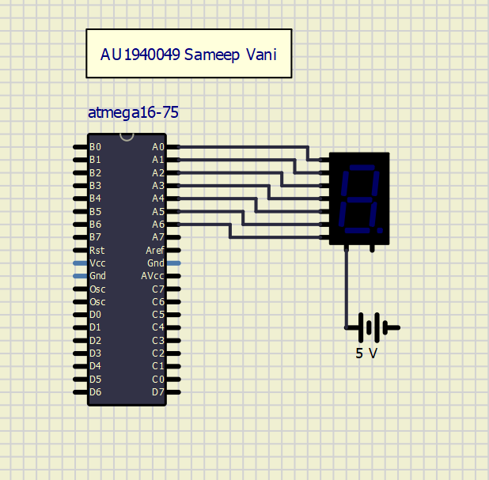

**Experiment 4**

Experiment Set-Up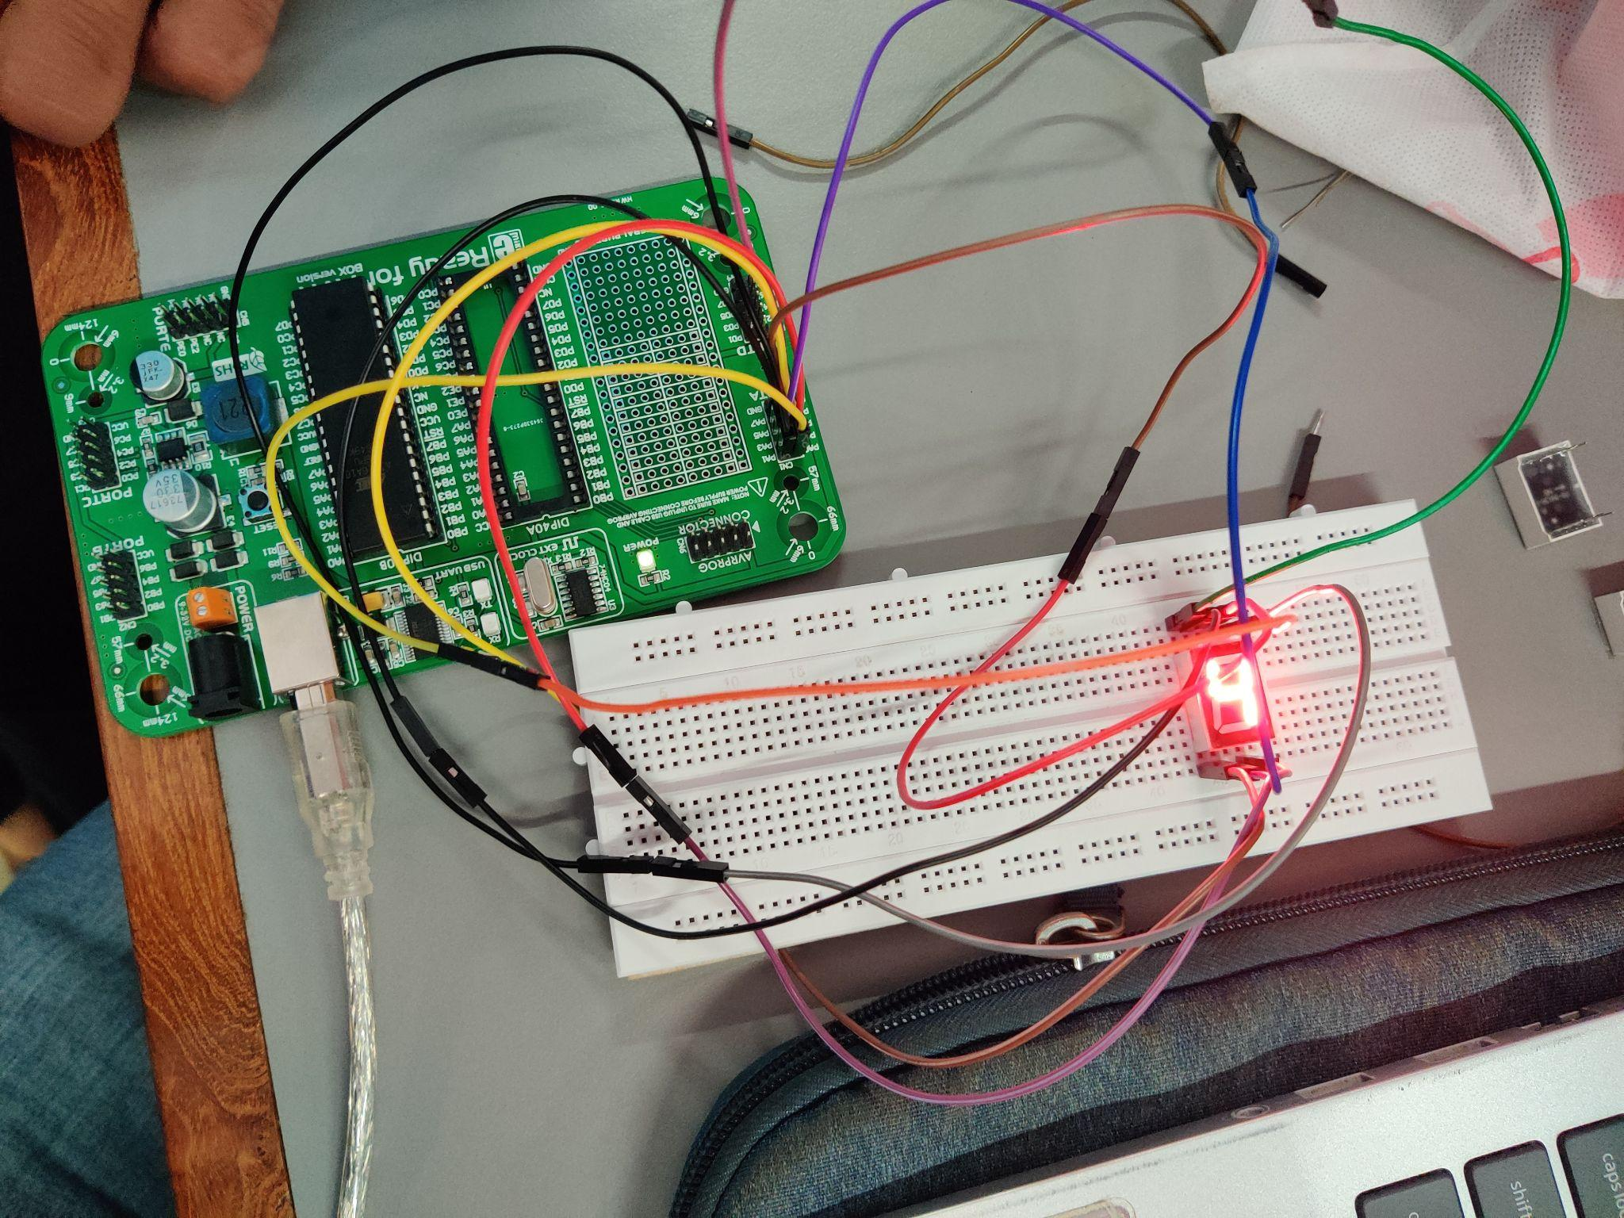

Description

In this experiment, the circuit created must be able to count from 9 to 0 on 7 segment LED. The connections are very similar to those in the previous experiment. Only difference here is that of code. As evident from the code below, the array created is a global variable. The logic is quite simple, based on common cathode configuration, the values of 9 - 0 in hex are computed and simply passed to PORTA with a delay of 1 second.

Video

[Link](https://drive.google.com/file/d/1jyDJzcu5rx92Yq55XgfMJEeKYdUSBoAb/view?usp=sharing)

Code

int arr[] = {0x90, 0x80, 0xF8, 0x82, 0x92, 0x99, 0xB0, 0xA4, 0xF9, 0xC0};

int i;

int main()

{

DDRA = DDRB = 0xFF;

while (1)

{

PORTB.b0 = 1;

for (i = 0; i < 10; i++)

{

PORTA = arr[i];

delay_ms(1000);

}

}

return 0;

}

Circuit Diagram

**Experiment 5**

Experiment Set-Up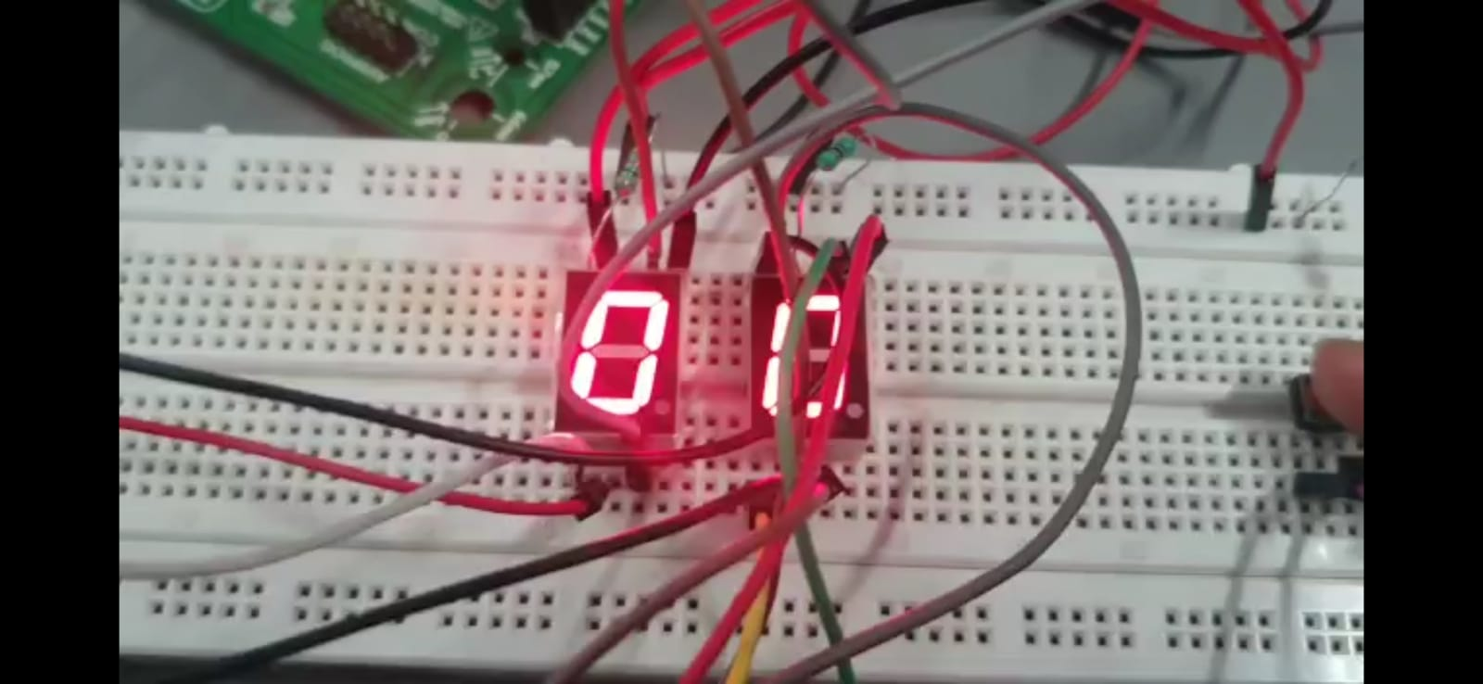

Description

In this experiment, the connections are similar to that in the previous two experiments. The only difference is that here there are two ports instead of one. PORTA and PORTB are used. Further, there is a switch that increments the counter and this count is displayed in the LEDs. Further, once the counter reaches 20, it gets reset and restarts from 0.

Video

[Link](https://drive.google.com/file/d/1G90BTKuz8AfUt5dJ9maEa1Wpkyd84hTX/view?usp=sharing)

Code

int arr[] = {0xC0, 0xF9, 0xA4, 0xB0, 0x99, 0x92, 0x82, 0xF8, 0x80, 0x90};

int count = 0;

void main()

{

DDRA = DDRC = 0XFF;

SREG.B7 = 1;

MCUCR = 0x03;

GICR = (1 << INT0);

while (1)

{

int temp = count;

PORTC = arr[temp % 10];

temp /= 10;

PORTA = arr[temp];

}

}

void INT0_VECT() org 0x002

{

if (count == 20)

{

count = 0;

}

count++;

}

Circuit Diagram